Documentation
Before proceeding I will document my actions in a chronological order the tasks that have been given to me.

Plan your Website
When planning my website I first followed the instructions listed to me in the work placement activity and gathered all the information that I may need to build my MVP which is seen below:
Plan your website
I want my personal website to communicate my skillset and experience to employers to showcase why I am employable.
A short introduction or biography
I am a Management graduate with a 2:1 degree and hands-on experience in data analysis, dashboard development, research, project coordination and stakeholder communication. Across public service, healthcare, finance and supply chain environments, I have built dashboards, analysed complex information and delivered evidence-based insights to support senior decision-making. My experience includes developing Power BI dashboards, creating Excel databases, producing research briefings, coordinating projects and events and communicating findings to stakeholders. I am a proactive and adaptable individual with strong analytical, problem-solving and organisational skills, who can learn at a fast pace and contribute effectively in a range of professional environments.
Education and Qualifications
BSc Management: Upper Second-Class Honours (2:1)
- Diploma in Professional Studies – awarded for year-long industrial placement
A-Levels: Maths (A) Economics (B) Politics (B)
Professional Development:
Analyst Builder – “Excel for Data Analytics” Certificate
Skills and Areas of Interest
Hard Skills
Finance & Data Tools
- Excel (advanced functions, PivotTables)
- QuickBooks (invoice and expense entry recording)
Software & Productivity
Microsoft PowerPoint, Word, SharePoint, Teams, Power BI, Outlook, Project Web App, Outlook and Whiteboard.
Research and Analysis
• Research & Evidence Analysis – Analysed data and evidence to identify local issues and priorities.
• Data Collection & Management – Built and consolidated constituency data to identify priority areas.
• Case Triage & Record Management – Recorded and categorised approximately 80 constituent enquiries for caseworker follow-up
Soft Skills
- Leadership – Leading events and coordinating team strengths
- Teamwork – Supported team success across multiple roles
- Time Management – Prioritised block work to meet tight deadlines across concurrent responsibilities
- Presentation Skills – Delivered high value presentations to senior stakeholders at GSK
• Adaptability – Quickly learned new tools (Power BI, Power Apps, SharePoint) during placement
• Initiative – Completed optional Power BI training
• Reliable & Diligent – Bronze External Recognition Award at GSK for quality contributions to the EM 2025 Transformation team.
• Stakeholder Communication – Communicated effectively with stakeholders across public service and business environments.
• Project and Event Planning – Developed event plans covering budgets, risks, accessibility and promotion.
Areas of Interest:
Data Analytics
Research
Process Improvement
Public Service
Projects or Examples of Work
Housing and Homelessness Analysis Croydon
Croydon West Data
Event Planning Exercise
2 Guided Projects on US Debt Tracker and NYC Bus Breakdown Project
Accredited Organisation Database
Evaluation of AO Reporting Platform
Expressions of Interest
OPEX Finance Dashboard
Work Experience
Office of Sarah Jones MP – London
MP Office Work Experience: 17/08/2026 – 21/08/2026
- Researched housing and homelessness in Croydon, producing an evidence-based briefing note which analysed key data, affected groups and stakeholder perspectives, which included over 3600 households in temporary accommodation and more than 8600 households awaiting social housing; finally presenting findings and potential actions for the MP.
- Built a constituency database for Croydon West, consolidating socioeconomic and public service data to identify priority areas and provide quantifiable evidence to support recommendations and decision making within the MP’s office.
- Designed an end-to-end event plan for a 100-person constituency event allocating a £1500 budget and developing the running order, accessibility provisions, registration process, risk management plan, staffing requirements and promotional strategy.
- Managed 80 constituent VoIP enquiries, accurately recording key information and triaging urgent cases to the appropriate caseworker to support timely follow up and resolution.
Commonwealth Secretariat – London
Partnerships Work Experience: 19/08/2025 – 02/09/2025
- Built an Excel pivot-table database consolidating data from 50+ member organisations, providing senior leadership with data driven insights to inform reaccreditation decisions.
- Conducted an evaluation of the AO reporting platform, identifying seven critical enhancements across user experience, security, reporting and support that were adopted ahead of rollout for 50+ accredited organisations.
- Drafted “Expressions of Interests” for 5 accredited organisations, synthesising organisational activities, achievements and alignment with Commonwealth values to support Board of Governor’s reaccreditation decisions.
GSK – London
Business & Supply Chain Placement: 04/07/2023 – 19/07/2024
- Developed two technical solutions (NPI checklist and OPEX Finance Dashboard) that enhanced process and financial transparency, supporting cross functional standardisation and enabling leadership to identify budget overspend and implement targeted cost reductions.
- Facilitated daily Tier 1–3 project escalation meetings for External Manufacturing 2025 and External Network Change programmes, ensuring agenda adherence.
- Delivered monthly presentations to NPI leadership on external supply chain issues impacting product launches, improving visibility of delivery risks and supporting proactive project management.
GamCare – London
Finance Assistant Summer Internship: 04/07/2022 – 30/09/2022
- Processed 200+ invoices and expense claims with zero missed deadlines.
- Compiled weekly donations reports formatted for Directors and Heads of Department.
City of London Corporation – London
Communications Support Work Experience: 05/06/2017 – 16/06/2017
- Conducted preliminary research for an article on UK-Spain economic ties ahead of the King of Spain’s state visit, providing evidence-based analysis to support external communications.
Professional Interests
Data Analytics
Research
Process Improvement
Public Service
Contact or professional profile links
Email: arjunpereira12@gmail.com
GitHub profile: https://github.com/DataLyte
LinkedIn: https://www.linkedin.com/in/arjun-pereira-393010232/
CV
Attach CV below.
Navigation
Designing a Portfolio Site to Get Hired
Think of the site as a 30-second pitch that expands into evidence. Employers skim before they read, so the structure needs to work for both modes.
The Flow (Order Matters)
1. Above the fold — instant clarity
- Your name + a specific title (not "Software Engineer" but "Frontend Engineer — React & Design Systems")
- One-line value prop: what you do + for whom + what result. E.g., "I build fast, accessible web apps for fintech teams."
- A clear next action: link to resume, or scroll cue
2. Proof, immediately after — not buried
- Your 3 best projects, not all 10. Quality over quantity signals judgment.
- Each project card should answer three things fast: what problem, what you did, what happened (impact/result). Screenshots or a demo GIF beat paragraphs.
3. Skills — contextual, not a wall of icons
- Better to show skills embedded in project descriptions ("built with React, deployed on AWS") than a standalone skills list nobody reads.
- If you include a skills section, group it (Languages / Tools / Domains) and keep it short.
4. Experience/resume
- Short work history with outcomes, plus a downloadable PDF resume — many recruiters still want the file for ATS/sharing internally.
5. About — brief, human, near the end
- A few sentences on your background and what you're looking for. This is trust-building, not the main event.
6. Contact — everywhere, not just one page
- Email, LinkedIn, GitHub visible in header/footer on every page. Don't make them hunt.

Wireframe Documentation
Once I had mapped out everything that I wanted to include in my website, I then decided to draw out with pen and paper what I wanted my website to look like, and be more selective with the information I want my website to contain
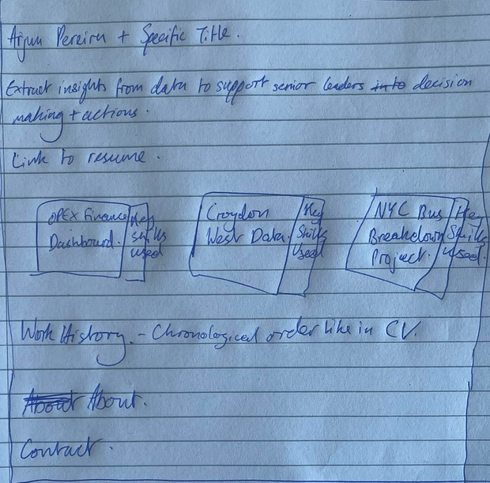
This was the initial sketch now I had to decide on a platform to build my wireframe.
I first tried the recommended Figma, however I felt that the user interface and navigation was slightly awkward to use so I changed my platform and then used Wix Studio. The user interface and navigation were much easier to use and get to grips on when building out the wireframe.
Before I started using Wix Studio I watched a tutorial on how to build a wireframe for a beginner: https://www.youtube.com/watch?v=ctOUj3bke3A , this was a helpful guide for someone who had not worked with this tool before.
After watching the tutorial the goal was to ensure that any recruiter/employer reading this page would reach out to me, to book for an interview or a call to discuss further. In terms of navigation for the user, I ensured it was a one page website so that the user wouldn’t have difficulty navigating through the multiple pages, in order to make the experience as easy as possible. Also I was unsure of the time on how to build a website with multiple pages and wasn’t sure how each page would look, so I decided to stick to one page.
When it came to building out the header, I wanted to keep things simple, warm and friendly with a friendly introduction, what I am aspiring to be and what I enjoy to do. I took inspiration from Sean Helpin’s personal branding page
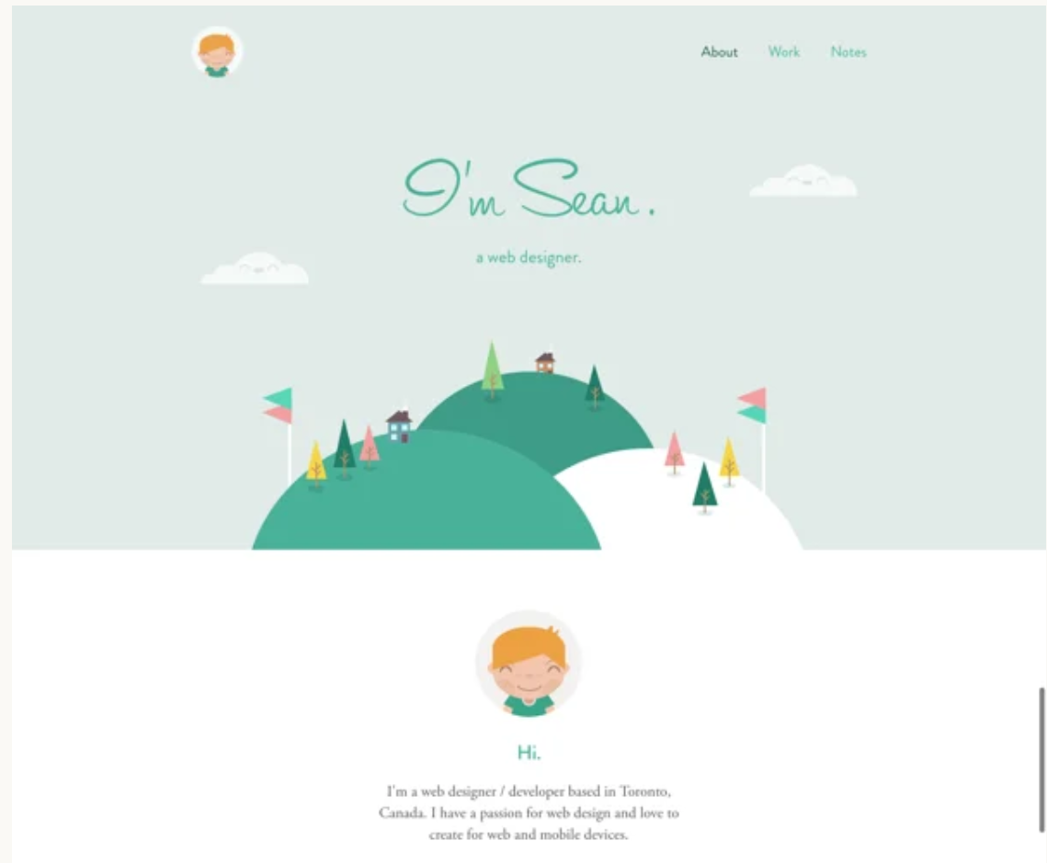

Therefore, I used warm colours so that my page is more desirable to read.
I also added a link to my CV, because the reader can get to know my professional history and experience very quickly through doing this.
I then wanted to clearly showcase my best work – which would include projects that I have done to display my skillset. These were OPEX Finance Dashboard, Croydon West Data and NYC Breakdowns and Delays project. The reason for choosing these projects were because these projects showcase my data analysis skills in the best way possible.
When deciding how to display these projects, after multiple trial and error to get the desired visual that I wanted, I settled on the collage wireframe below.
This is because the collage wireframe allowed me to state the project, include a visual from said project as well as outline the purpose, outcome and skills acquired, in an easy to read and clear manner. I had tried other elements before the collage, however I struggled with formatting an image of said project within the diagram. As well as this the collage was the best visual to get a clear understanding of the project and what skills I developed through completing this project.
Unfortunately I didn’t have a link to my project, with the OPEX Finance Dashboard as this was completed 2 years ago and I don’t have access to the Power BI dashboard I made at GSK, which is why a link is not attached to this project, while links are attached to the other projects.
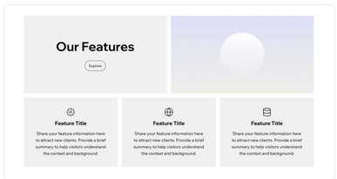
I kept the structure uniform with all the projects because that way it would be easier for the reader to follow along and I kept it short and snappy as to not bore the reader.
I then decided to include my entire work history using a list wireframe, this section is just copy and pasted from my CV, which is an issue because I have a link to my CV already, so the reader will be reading the same thing. I need to change this to show perhaps different things that I did there that were not on my CV, but due to time I just copy and pasted my CV.
Finally finished off with contact details and LinkedIn profile at the end.
Issues:
The formatting of the website does look funny on mobile as wireframe was built with the perspective of being opened on a desktop. I need to find a way to make it easy to read on the mobile viewing.
I want this wireframe to achieve the goal of getting employers and recruiters to reach out to me to discuss an interview or a call. How can I tailor the wireframe to achieve this.
What can I do instead of the work history section.

